**НАЗВАНИЕ РУБРИКИ ЖУРНАЛА | JOURNAL COLUMN NAME**

**Научная статья | Original paper**

# Predictors of successful graduation and overall well-being of graduates

**V.A. Ivanov**1**, V.N. Petrov**1, 2

1 Saint Petersburg State University, Saint Petersburg, Russian Federation

2 Moscow State University of Psychology and Education, Moscow, Russian Federation

 ivanov@yandex.ru

## *Abstract*

**Context and relevance.** Motivation is a significant predictor of student achievement and general well-being. The theoretical basis of the study was self-determination theory, which promotes sources of both autonomous and controlled motivation in the context of learning activities. **Objective.** To identify the influence of motivational factors on successful completion of higher education and the level of satisfaction with this process. **Hypothesis.** The quality of students’ motivation, their satisfaction with the learning process and their intentions to complete their education are positively correlated with autonomous motivation and negatively correlated with controlled motivation. **Methods and materials.** The study involved 500 undergraduate students at humanities universities (M = 20,8, SD = 4,2, 53% female). Autonomous and controlled motivation for postgraduate study was assessed using a battery of questionnaires (Scales of Motivational Regulation UPLOC, Satisfaction of Basic Psychological Needs D-N2S), and academic performance and graduation intentions and satisfaction were also recorded. **Results.** The results showed that autonomy needed satisfaction was a predictor of both motivation to learn and learning satisfaction, whereas competence needed satisfaction was a predictor of completion intentions. **Conclusions.** The study and observation of motivational factors has been shown to play a key role in predicting learner success. It is recommended that faculties pay attention to learners' basic psychological needs for autonomy and competence, which promote voluntary learner engagement and successful outcomes.

***Keywords:*** well-being, learning, self-determination theory, motivation, students

**Funding.** The study was supported by the Russian Science Foundation, project number 00-00-00000, https://rscf.ru/en/project/00-00-00000/.

**Acknowledgements.** The authors are grateful for assistance in data collection T.Yu. Sidorov.

**Supplemental data.** Datasets аvailable from https://______

**For citation:** Ivanov, V.A., Petrov, V.N. (20__). Predictors of successful graduation and overall well-being of graduates. *Cultural-Historical Psychology,* *__*(__)*,* __—__. (In Russ.). https://doi.org/10.17759/chp.2025210___

# Название статьи

**В.А. Иванов**1**, В.Н. Петров**1, 2

1 Санкт-Петербургский государственный университет, Санкт-Петербург, Российская Федерация

2 Московский государственный психолого-педагогический университет, Москва, Российская Федерация

 ivan@yandex.ru

## *Резюме*

**Контекст и актуальность. […]**

***Ключевые слова:*** […]

**Финансирование.** […].

**Благодарности.** […].

**Дополнительные данные.** […]

**Для цитирования:** Иванов, В.А., Петров, В.Н. (20__). Название статьи. *Культурно-историческая психология, __*(_)*,* __—__. https://doi.org/10.17759/chp.2025210___

### Introduction

This section presents the introduction. The introduction should describe the specific research problem and address the following questions: Why is this issue important? How does this study relate to previous research in the field? What are the main and additional hypotheses and research objectives? The introduction should also provide a brief literature review, highlighting how this study differs from previous work and what it has in common with them. The theoretical frameworks underpinning the study should be clearly outlined.

### Materials and methods

This section provides a detailed description of the research methodology. A comprehensive explanation of the methods used allows readers to evaluate their appropriateness, reliability, and validity. It is advisable to include subsections in the Materials and methods section. Common subsections include: Participants (description of the sample, including age, gender, sample size, inclusion/exclusion criteria, etc.). Procedures (description of experimental manipulations, interventions, data collection methods, sample selection procedures, study design characteristics, etc.). For quantitative research, statistical analysis methods should also be described.

### Results

The results of the study are discussed here. Examples of table and figure layout are presented below. If there is only one table and/or figure, they are not numbered. If there are more, they should be numbered. All captions and explanations are given in English.

All captions and explanations are given in English.

Table

**Relationship between the indicators of creativity and aggression in students (N = 80)**

|  |  |  |  |  |  |  |  |  |
| --- | --- | --- | --- | --- | --- | --- | --- | --- |
| **Parameters** | ***M* (*SD*)** | **1** | **2** | **3** | **4** | **5** | **6** | **7** |
| **Creativity** | | | | | | | | |
| 1. Fluency | 7,43 (2,90) | 1 | - | - | - | - | - | - |
| 2. Flexibility | 2,56 (0,95) | 0,47* | 1 | - | - | - | - | - |
| 3. Originality in pro social situations | 3,27 (2,44) | 0,79* | 0,63* | 1 | - | - | - | - |
| 4. Originality in situations with negative connotation | 0,38 (0,63) | 0,30* | 0,35* | 0,16 | 1 | - | - | - |
| 5. Overall originality | 3,47 (2,90) | 0,78* | 0,59* | 0,91* | 0,33* | 1 | - | - |
| **Aggression (Buss—Perry)** | | | | | | | | |
| 6. Aggression | 5,90 (2,43) | 0,57* | 0,55* | 0,33* | 0,41* | 0,49* | 1 | - |
| 7. Hostility | 3,59 (0,73) | 0,27* | 0,42* | 0,38* | 0,44* | 0,49* | 0,45* | 1 |

*Note:* «*» — correlation is significant at the 0,01 level (two-sided).

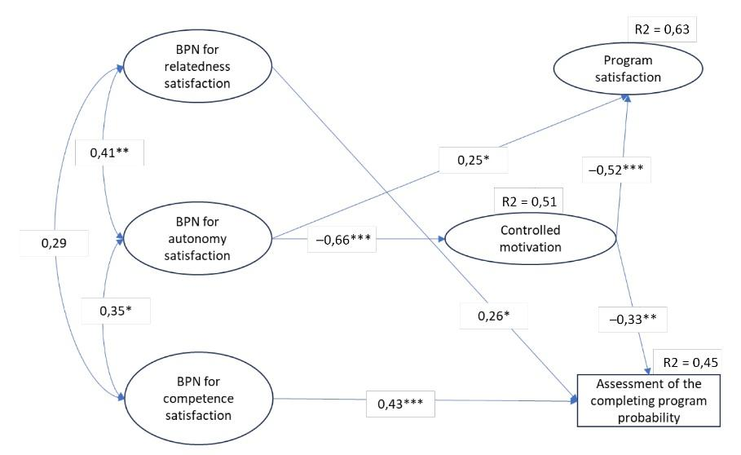

**Fig.** Structural model of the relationship between satisfaction with PhD studies, completion intentions, basic psychological needs satisfaction, and controlled motivation: «*» — *p* < 0,05; «*» — *p* < 0,01; «*» — *p* < 0,001.

### Discussion

This section analyses, interprets, and evaluates the study's results. Begin the Discussion section with a clear statement regarding whether the data support the primary and additional hypotheses or not. Similarities and differences between this study’s findings and those of other researchers should be used to conceptualise, validate, and refine the conclusions.

### Conclusions

This section concisely summarises the study's findings and its future prospects. Typically, it should not exceed 10% of the total text length. It should include a restatement of the key findings and their significance for the field. This section should address the research questions, hypotheses, and objectives stated in the introduction. Additionally, it can briefly discuss: why the research problem is significant (as indicated in the introduction); what broader issues beyond the specific research area could be addressed based on these findings; which future research projects might (or might not) build upon these results; the potential future directions for this research.

**Limitations.** Possible issues in generalization of results, e. g., sample size, limited access to data.

## References

1. Gervits, A.E., Leont'ev, D.A. (2017). Experiences in loneliness and in company depending on attitudes towards loneliness. In: O.V. Solov'eva, T.G. Stefanenko (Ed.), *Innovative Resources of Social Psychology: Theories, methods, рractices: Collection of scientific works* (pp. 409—414). Moscow: MSU. (In Russ.).
2. Leontiev, D.A., Osin, E.N., Dosumova, S.S., Rzaeva, F.R., Bobrov, V.V. (2018). Study-related experiences and their association with psychological well-being. *Psychological Science and Education, 23*(6), 55—66. (In Russ.). https://doi.org/10.17759/pse.2018230605
3. Rubtsov, V.V. (2024). *Social-genetic psychology of learning interactions: Selected articles, speeches, projects. Vol. 1*. Moscow: Gorodets. (In Russ.). URL: https://psyjournals.ru/nonserialpublications/sgpli2024 (viewed: 10.09.2024).
4. Shumakova, N.B., Shcheblanova, E.I., Sorokova, M.G. (2023). *«Classroom Climate»: Russian language version of the modified School Climate Questionnaire: Data set.* RusPsyData: Psychological Research Data and Tools Repository. (In Russ.). https://doi.org/10.48612/MSUPE/f3x6-d81x-uuu9
5. Sheldon, K.M., Osin, E.N., Gordeeva, T.O., Suchkov, D.D., Sychev, O.A. (2017). Evaluating the dimensionality of self-determination: Theory’s relative autonomy continuum. *Personality and Social Psychology Bulletin,* *43*(9), 1215—1238. https://doi.org/10.1177/0146167217711915

## Information about the authors

*Vitalyi A. Ivanov*, Candidate of Science (Psychology), Leading Research Associate, Associate Professor, Chair of Psychology, Department of Psychology, Saint Petersburg State University, Saint Petersburg, Russian Federation, ORCID: https://orcid.org/0000-0002-0777-1111, e-mail: ivanov@yandex.ru

*Vladimir N. Petrov,* PhD in Psychology, Professor, Chair of Psychology, Department of Psychology, Saint Petersburg State University, Saint Petersburg, Russian Federation; Leading Research Associate, Center of Applied Psychological Studies, Moscow State University of Psychology and Education, Moscow, Russian Federation, ORCID: https://orcid.org/0000-0002-0777-1122, e-mail: petrov@yandex.ru

## Информация об авторах

*Виталий Алексеевич Иванов*, кандидат психологических наук, доцент кафедры общей психологии, факультет психологии, Санкт-Петербургский государственный университет (ФГБОУ ВО СПбГУ), Санкт-Петербург, Российская Федерация, ORCID: https://orcid.org/0000-0002-0777-1111, e-mail: ivanov@yandex.ru

*Владимир Николаевич Петров,* PhD в психологии, профессор кафедры общей психологии, факультет психологии, Санкт-Петербургский государственный университет (ФГБОУ ВО СПбГУ), Санкт-Петербург, Российская Федерация; ведущий научный сотрудник Центра прикладных психолого-педагогических исследований, Московский государственный психолого-педагогический университет (ФГБОУ ВО МГППУ), Москва, Российская Федерация, ORCID: https://orcid.org/0000-0002-0777-1122, e-mail: petrov@yandex.ru

## Contribution of the authors

Vitalyi A. Ivanov — ideas; annotation, writing and design of the manuscript; planning of the research; control over the research.

Vladimir N. Petrov — application of statistical, mathematical or other methods for data analysis; conducting the experiment; data collection and analysis; visualization of research results.

All authors participated in the discussion of the results and approved the final text of the manuscript.

## Вклад авторов

[…]

## Conflict of interest

The authors declare no conflict of interest.

## Конфликт интересов

[…]

## Ethics statement

The study was reviewed and approved by the Ethics Committee of Moscow State University of Psychology and Education (report no, 2025/01/10).

## Декларация об этике

[…]

|  |  |
| --- | --- |
| Поступила в редакцию __.__.2025 | Received 2025__.__. |
| Поступила после рецензирования __.__.2025 | Revised 2025__.__. |
| Принята к публикации __.__.2025 | Accepted 2025__.__. |
| Опубликована __.__.2025 | Published 2025__.__. |